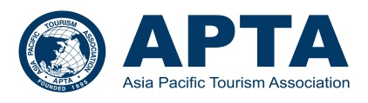
APTA 2020 Chiang Mai Conference

SPONSORSHIP APPLICATION FORM

In order for your organization to be a sponsor of APTA 2020 conference, please provide the following information and email the completed form to APTA Assistant Secretary, at aptasecretary.assist@gmail.com. Details regarding the payment will be informed upon the receipt of this form.

Name of Organization:
Sponsorship Type | [ √ ] Institutional Sponsorship (USD 1,500)
Contact Personnel
Title:
Name

 | First Name |  | Last Name
Address 1
Address 2
City
Country
ZIP Code
Telephone (incl. int’l code)
Fax Number (incl. int’l code)
Email
Free Registration for…
 | (Name of person who will get the free registration benefit)

Persons who will get APTA Member Benefit
Title:
Name

 | First Name |  | Last Name
Email

Title:
Name

 | First Name |  | Last Name
Email

Should you have any questions regarding the sponsorship, please contact the APTA Assistant Secretary, at aptasecretary.assist@gmail.com.

